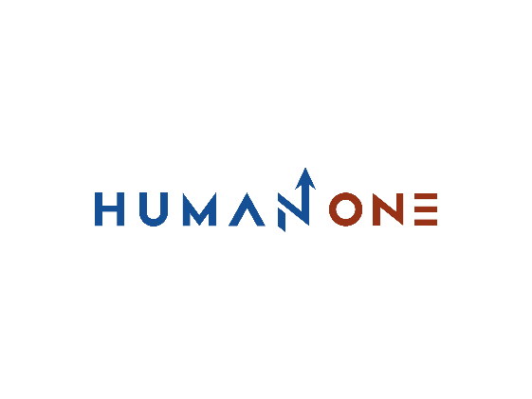

Services

Big Data & analytics

Platform Development

Expertise

**EN**

**FR**

Get in touch

Company

Cloud

Devops

Machine learning & IA

UI/UX Design

Internet Of Things

Location Based Services

Blockchain



# **Blockchain Development**

Build a strong core for your next application with HumanOne, a blockchain services provider recognized for cross-industry expertise and a drive for continuous improvement. We’ll help you shape your vision and ideas into viable use cases and suggest the optimal technology stack, team composition, and product design as part of our initial blockchain consulting services – all before digging into development. From ideation to co-creation, our team will be 100% invested in understanding your project’s specifications, goals, and needs in order to translate them into custom blockchain solutions that will rock the market.

Let’s Talk



What types of blockchain applications can we build? Well, that’s your call! Our team is ready to step in at any stage of product development — MVP, pilot, full-scale implementation, or product elaboration — and take full ownership of the project through its successful completion.  
Our custom blockchain development services are robust, but not all-mighty though. The current tech stack includes the following blockchain platforms and protocols: Corda, Ripple, Bitcoin, Ethereum (including Solidity) and Hyperledger.

**Enterprise blockchain**

Build a distributed registry tailored to your organization's needs. Private or hybrid, 100% tamper-proof and protected by a new technology backbone for secure collaboration, data exchange and storage.

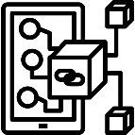

**Blockchain wallets**

Launch a standalone cold wallet for crypto-currencies or integrate a secure multi-coin blockchain wallet into your existing product. The HumanOne UX/UI team will ensure its attractive interface, while our blockchain development team will make it fully secure to use.

**Decentralized apps (dApps)**

Enter a whole new world of decentralized applications that run on open standards. Deploy new user-centric products on public blockchain networks. Reduce operational costs, increase security of customer data, and eliminate centralized points of failure.

**Smart contracts**

Say goodbye to repetitive, low-value business processes. Engage our team to develop self-executing EVM smart contracts that cannot be breached, compromised or ignored. Make transactions secure, fast and reliable without intermediaries.



**Blockchain-based marketplaces**

The technological nature of blockchain as a shared ledger naturally facilitates the creation of P2P, B2B and B2C marketplaces. Explore the new reality of the "shared economy" where every transaction is cryptographically protected, transparent, fraud-free and low cost.

**Business blockchain platforms**

Supply chain management, provenance tracking, digital identity management, health data storage, automated insurance quotes, or a vote in an election, the use cases for commercial off-the-shelf blockchain are multiplying. Will you be at the forefront of technological innovation?

Let’s talk feasible blockchain implementation

Get in touch

**Exemples de plateforme basées sur le développement de la blockchain**

**Cas d’utilisation de la blockchain développement de la blockchain**

